Internship Report

**Web Development Internship**

At Navkar Business Services

Submitted in partial fulfilment for the degree of Bachelor of Technology in Electronics and Telecommunication/ Electronics Engineering

Submitted by

Sanjana Ravindra Sawant

Roll No. 27



Usha Mittal Institute of Technology

S.N.D.T. Women’s University

Juhu Tara Road, Santacruz (West),

Mumbai-400049

2019-2020

**CERTIFICATE**

This is to certify **Sanjana Ravindra Sawant** have completed the internship satisfactorily in partial fulfillment for the Bachelor Degree in Electronics and Communication/ Electronics Engineering un- der the guidance of Mrs. Arundhati Mehendale during the year 2023 as prescribed by S.N.D.T. Women’s University, Mumbai.

|  |  |  |
| --- | --- | --- |
| Guide  Mrs. Arundhati Mehendale | External 1 | External 2 |

**Acknowledgment**

**Table of Contents**

**1.** **Objectives of Internship** 5

**2.** **Introduction to Company** 6

**3.** **Company Profile** 7

**4.** **Introduction to Web Development** 8

**5.** **Types of website development** 8

**a)** **Front-end development** 9

**b)** **Back-end development** 9

**6.** **Web Development Process** 10

**7.** **Introduction of Internship Project** 13

**a)** **Purpose** 13

**b)** **Scope** 13

**c)** **Definition** 14

**d)** **Technologies to be used** 14

**e)** **Identification of needs** 15

**f)** **User characteristics** 15

**g)** **Software Development Process** 16

**h)** **User Case Diagram** 17

**i)** **Activity Diagram** 18

**8.** **Weekly Report** 19

# **Objectives of Internship**

# **Introduction to Company**



Navkar Business Services was founded in 2016 and since that time has grown into the largest Company in the area. We are an assertive Company providing our clients a full range of services. Our offices are located in the Lower Parel Mumbai east. However, we serve a wide variety of clients located throughout the United States. We maintain close and open relationships with each of our clients. Our commitment is to provide the highest quality services while retaining a small-town atmosphere. Navkar Business Services is a registered of the Municipal Corporation of Greater Mumbai. Professionalism: Our company is one of the leading company in the area. By combining our expertise, experience and the energy of our staff, each client receives close personal and professional attention. Our high standards, service and specialized staff spell the difference between our outstanding performance, and other firms. We make sure that every client is served by the expertise of our whole company.

# **Company Profile**



Navkar Business Services was founded in 2016. We are an assertive Company providing full range of operational and all sorts of back hand support services to US based Residential Property Management companies.

Our commitment is to provide the highest quality services while retaining a small-town atmosphere. By combining our expertise, experience and the energy of our staff, our client receives close personal and professional attention. Our high standards, service and specialized staff spell the difference between our outstanding performance, and other firms.

# **Introduction to Web Development**

Web development refers to the creating, building, and maintaining of websites. It includes aspects such as web design, web publishing, web programming, and database management. It is the creation of an application that works over the internet i.e., websites.

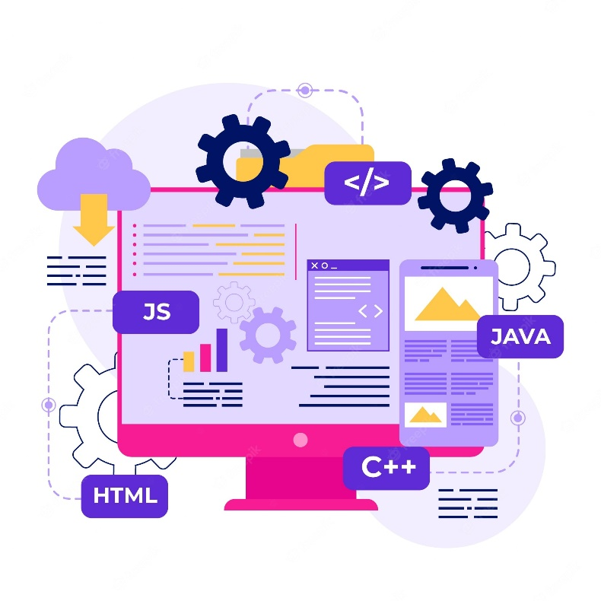

The word Web Development is made up of two words, that is:

Web: It refers to websites, web pages or anything that works over the internet.

Development: It refers to building the application from scratch.

# **Types of website development**

There are a few different types of website development, but the most common types are front-end development and back-end development. This refers to what a user sees on the website, and what a user doesn’t see.

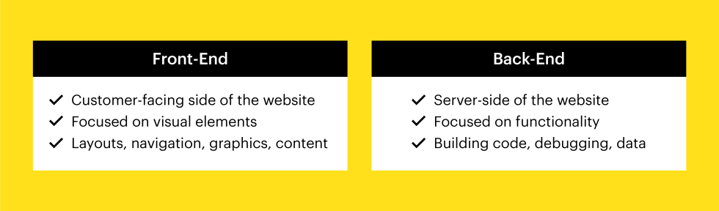

## **Front-end development**

Front-end development is what the user will see and interact with on the website. This typically involves website design and includes the website’s colors, layout, fonts, and images. If you’re a front-end developer, that means you're responsible for having a website look and feel a certain way.

Front-end development involves using tools like Photoshop and Illustrator to create the website design. A front-end developer will also need to understand various programming languages, or coding languages, like HTML, CSS, and JavaScript. Understanding these programming languages is crucial so that a user can actually interact with the website with buttons and navigation menus.

## **Back-end development**

Back-end development is what the user doesn’t see with the website. Back-end development is focused more on how the website works, rather than how it looks. This can include user authentication, network and hosting configuration, database interaction, and anything else that goes on behind the scenes of a website.

A back-end developer is responsible for making sure everything is running smoothly within the website. For example, if people upload their information onto a website, a back-end developer is responsible for compiling and analyzing that data. A back-end developer needs to be familiar with server-side languages, like Ruby, .Net, and Python.

Another type of website development is full-stack development. Full-stack developers can do both front-end and back-end development. A full-stack developer must be knowledgeable of both programming languages and server-side languages and needs to be able to handle all aspects of website development.

Because hiring one person to the job is obviously much easier than hiring two people, many businesses prefer to hire full-stack developers. However, it’s a very in-demand job in the tech industry.

# **Web Development Process**

What does the website development process entail?

The development process can look different for every website, but for the most part, it will entail the following 8 steps:

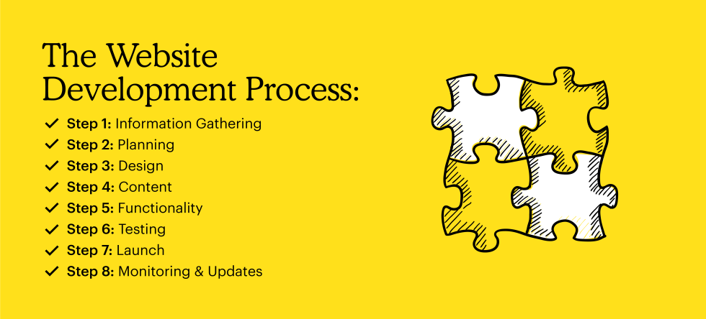

Step 1: Information gathering

Before you can actually build a website, you need to gather information. This will include your purpose, main goals, and target audience.

Your purpose is essentially the reason behind creating this website. Is it for self-promotion or to provide information about a certain topic? Your goals are what you want to accomplish with this website. Having goals will give you a better idea of how to go about creating the website and what content to include. Your target audience is who your website is going to appeal to. Every business has a target audience, so make sure you figure out who yours is before actually creating the website. Imagine your ideal customer, including their age, gender, and interests.

Step 2: Planning

Once you’ve gathered the basic information for your website, you then need to start planning it out. Using the information from the first step, you’ll create a sitemap. A sitemap is a list of all the topics and sub-topics of your website. The sitemap will help you be able to visualize the website and how a user can jump from one page to another. This step is crucial so that you can create an attractive website that is easy to navigate.

Step 3: Design

After you’ve planned the outline of the website, then you need to figure out how it’s going to look. This will include all visual content, such as photos and videos. Be sure to keep in mind your target audience when planning the design of your website.

For example, a public relations brand will have a very different website than a brand with a target audience of pet owners. You want your website to be catered towards your target audience’s wants and needs.

Step 4: Content

The content that you have on your website is one of the most important aspects of a website. Your content will convey your message to your audience and encourage them to use your website. But before you can write your content, you need to figure out your goals and purpose, which is why step 2 is so important. Your content should be relevant and interesting enough that your users keep coming back.

Step 5: Functionality

At this step is when you’ll actually start to build your website. This is also when all the above steps will come together to create the look and functionality of the website. You want your website to be user-friendly and easy to get around. The homepage will usually be created first, and then all the sub-pages will come after. You also need to make sure the website can be accessible from both a desktop and mobile phone.

Step 6: Testing

Once the website has been successfully created, it’s not quite ready to be launched just yet. It needs to be tested first. Testing the website can be a tedious process, but it’s necessary to make sure the website is running properly. During this step, you’ll test all the links and buttons on the website, check the spelling of everything, and make sure the website looks the same on a phone than it does on a computer.

Step 7: Launch

After you’ve thoroughly checked the website and tested it a few times, now comes the exciting part: actually launching it. To launch your website, you need to upload it to a server. Once it’s uploaded, you’ll want to quickly run one last test just to double check that everything is correct. The website will now be viewable to the public.

Step 8: Monitoring and updates

Even after you successfully launch your website, it’s still crucial to go back and check it from time to time. Mistakes can happen, and it’s important to stay on top of the website to make sure it remains in good shape. You want to fix any problems as quickly as possible and always keep your website up to date.

# **Introduction of Internship Project**

## **Purpose**

The current process of collecting and verifying vehicle documents for parking management can be time-consuming and inefficient, particularly for managers who are responsible for this task. In order to streamline this process and improve efficiency, a new standard way to collect and enforce parking documents through digitalization can be implemented. This can reduce operational time and effort by eliminating the need for manual collection, verification, and emailing of documents. The digitalization process can involve setting up a centralized database where vehicle owners can submit their documents online, and the system can automatically verify and update the status of each document. This can enable managers to quickly and easily access the required information, and enforce parking regulations more effectively. Overall, this approach can help to save time and resources, while improving the overall efficiency and accuracy of parking document management.

## **Scope**

The goal of implementing a digital system for parking document management is to streamline the manual processes of documentation, making it faster and more efficient for managers. By digitizing the process, data can be collected and analyzed in real-time, allowing for data-driven decisions to be made. This can save time for managers, who will no longer need to collect and verify documents manually, and can instead focus on other important tasks. Furthermore, by creating a direct contact between tenants and the digital system, the documentation process can be made more accessible and convenient for all parties involved. Overall, the goal of this digitalization process is to improve efficiency, accuracy, and accessibility of parking document management, ultimately leading to a better parking experience for everyone involved.

* To streamline the entire manual processes of documentation into digitalization.
* To make data-driven decisions with real-time data.
* To save the time of manager.
* To create direct contact with tenants for the documentation process.

## **Definition**

To ensure the accuracy and validity of parking documentation, it is important to verify the documents before allocating parking space and stickers to tenants. This involves checking whether the documents are still relevant and not expired. Only when the documents are deemed relevant and up-to-date, stickers and parking spaces will be provided to the tenants. Additionally, to maintain the accuracy and validity of parking documentation, tenants will receive email notifications 30 days prior to the expiration date of their documents. This will remind tenants to provide new relevant documents before their expiration date in order to continue using the parking facilities. By ensuring that all parking documents are verified and up-to-date, the parking management system can maintain its integrity and provide a better parking experience for everyone involved.

## **Technologies to be used**

To implement the digital parking management system, a range of technologies will be used. For the frontend, HTML, CSS, and Jsp will be utilized to create a user-friendly interface for tenants to access and submit their parking documents. For the backend, Java and Spring will be used to handle the logic and processing of the data submitted by tenants. The database system will be based on MYSQL version 8.0.20, which will store all the relevant parking data, including tenant information and parking documents. The server technology will be Tomcat version 8.5.84, which will be used to host the digital parking management system. The IDE for development will be Spring Boot version 4.17, with the Java Development Kit (JDK) version 8 and MYSQL Workbench also being utilized. By using these technologies, the digital parking management system can be developed and deployed efficiently and effectively, ensuring a smooth and seamless parking experience for tenants.

* **Frontend**: HTML, CSS, Jsp.
* **Backend**: Java, Spring.
* **Database**: MYSQL (Ver 8.0.20).
* **Server**: Tomcat (Ver 8.5.84).
* **IDE**: Spring Boot (Ver 4.17), JDK (Ver 8), MYSQL Workbench.

## **Identification of needs**

The digital parking management system project requires two primary functions. The first function is to provide management with an efficient way to keep track of parking details, including tenant information, parking space allocation, and documentation status. By having a centralized database system that stores all relevant parking data, management can easily access and manage this information, saving time and resources. The second function is to establish direct contact between tenants and the digital system, making the documentation process more accessible and convenient for all parties involved. By creating a user-friendly interface for tenants to submit their parking documents online, the process can be streamlined and made more efficient. Overall, these two functions are crucial to the success of the digital parking management system, enabling both management and tenants to access and manage parking details in a more efficient and convenient way.

This project essentially needs functions:

* + It will be helpful for management to keep track of parking details.
  + Direct contact with tenants for the documentation process.

## **User characteristics**

The digital parking management system will have two primary user roles: Admin and Registered User. Admin users will be able to login and logout of the system and manage the entire parking system. This will include the ability to add, view, edit, and update the user database, as well as accept or reject documents submitted by tenants. Admin users will also have the ability to allot parking spaces to tenants, ensuring that parking is efficiently managed within the system.

On the other hand, Registered Users will also be able to login and logout of the system, but will have limited access to the system. They will be able to view and upload their parking documents, as well as update them if necessary. This will enable tenants to easily manage their parking documents and ensure that they are always up-to-date.

In summary, the digital parking management system will have two distinct user roles with different levels of access and functionality. Admin users will have complete control over the system and the ability to manage parking details for all tenants, while Registered Users will have limited access to the system, allowing them to manage their own parking documents efficiently and conveniently.

ADMIN: Can login/logout.

Can manage the parking system.

Can add/view/edit/update users database.

Can Accept/Reject Documents

Can allot parking space to tenants.

REGISTERED USER: Can login/logout.

Can view/upload/update documents.

## **Software Development Process**

The digital parking management system will utilize two software development models to ensure effective development and reduce errors and risks. The first model, the Prototype Model, will be used primarily for the UI (User Interface) part of the project. This model is designed to create a simple data processing application that can easily detect missing functionality. This will allow developers to quickly identify any shortcomings in the UI and make necessary adjustments, ensuring a more effective and user-friendly system.

The second model, the Evolutionary Model, will be used for the object-oriented development of the system. This model is designed to reduce the error and risk associated with software development by allowing for continuous testing, evaluation, and modification. With the Evolutionary Model, the system will be developed in stages, with each stage building on the previous one. This approach will enable developers to identify and address any issues early on, reducing the risk of errors or other problems in the final system.

Overall, the combination of these two software development models will ensure that the digital parking management system is developed in a comprehensive and effective manner, with minimal risk of errors or other issues.

Prototype model: Used for UI (User Interface) part of the project.

Simple data processing application.

Easily detect missing functionality.

Evolutionary model: Used for object-oriented development.

Reduce the error/risk of software

## **User Case Diagram**

## **Activity Diagram**



# 

# **Weekly Report**

**JANUARY**

|  |  |  |
| --- | --- | --- |
| **Week 1** | | |
| **Day** | **Duration (**09:30-06:30 UST) |  |
| 09.January.2023 | 8 hours | Induction |
| 10.January.2023 | 8 hours | Collect parking portal API requirements. |
| 11.January.2023 | 8 hours | Draw unified modeling language and activity diagram element of parking portal. |
| 12.January.2023 | 8 hours | Studied DAO layer.  decided softwares which having to be use for developing parking portal. |
| 13.January.2023 | 8 hours | Download softwares.  set environment for each softwares.  Created Login.jsp page.  Created database. |

|  |  |
| --- | --- |
| **Week 2** | |
| 16. January.2023 |  |
| 17. January.2023 | Studied API different methods. |
| 18. January.2023 | Solved errors  Created web servlet. |
| 19. January.2023 |  |
| 20. January.2023 |  |

|  |  |
| --- | --- |
| **Week 3** | |
| 23. January.2023 |  |
| 24. January.2023 |  |
| 25. January.2023 |  |
| 26. January.2023 |  |
| 27. January.2023 |  |

|  |  |
| --- | --- |
| **Week 4** | |
| 30. January.2023 |  |
| 31. January.2023 |  |

**FEBRUARY**

|  |  |
| --- | --- |
| **Week 1** | |
| 01.feb2023 |  |
| 02.feb2023 |  |
| 03.feb2023 |  |

|  |  |
| --- | --- |
| **Week 2** | |
| 06.feb.2023 |  |
| 07.feb.2023 |  |
| 08.feb.2023 |  |
| 09.feb.2023 |  |
| 10.feb.2023 |  |

|  |  |
| --- | --- |
| **Week 3** | |
| 13.feb.2023 |  |
| 14.feb.2023 |  |
| 15.feb.2023 |  |
| 16.feb.2023 |  |
| 17.feb.2023 |  |

|  |  |
| --- | --- |
| **Week 4** | |
| 20.feb.2023 |  |
| 21.feb.2023 |  |
| 22.feb.2023 |  |
| 23.feb.2023 |  |
| 24.feb.2023 |  |

|  |  |
| --- | --- |
| **Week 5** | |
| 27.jan.2023 |  |
| 28.jan.2023 |  |

**MARCH**

|  |  |
| --- | --- |
| **Week 1** | |
| 01.mar.2023 | Learned Unix and shell commands and scripts |
| 02.mar.2023 | Design front-end of Parking portal user login page |
| 03.mar.2023 | Merged front-end and back-end of login page |

|  |  |
| --- | --- |
| **Week 2** | |
| 06.mar.2023 | Learned AJAX working.  Created table for testing inner join query.  Created stored procedure for property name and property code. |
| 07.mar.2023 | Created ajax project for testing dropdown search. |
| 08.mar.2023 | Assigned foreign key relation to the database tables. |
| 09.mar.2023 | Modified frontend of user login page. |
| 10.mar.2023 | Learned different types of ajax methods and properties.  Created dynamic web project for file upload option.  Add jars files to the class path.  Created frontend for file upload.  Created sample database for file upload. |

|  |  |
| --- | --- |
| **Week 3** | |
| 13.mar.2023 | Added form tag to jsp page.  Created servlet for file upload. |
| 14.mar.2023 | Created test project for property name dropdown search.  Created frontend for dropdown.  Created jsp for dropdown |
| 15.mar.2023 | Worked on property name dropdown search.  Created query for property name dropdown. |
| 16.mar.2023 | Added unit number dropdown search in dropdown search project.  Created query for unit dropdown. |
| 17.mar.2023 |  |

|  |  |
| --- | --- |
| **Week 4** | |
| 20.mar.2023 |  |
| 21.mar.2023 |  |
| 22.mar.2023 |  |
| 23.mar.2023 |  |
| 24.mar.2023 |  |

|  |  |
| --- | --- |
| **Week 5** | |
| 27.mar.2023 |  |
| 28.mar.2023 |  |
| 29.mar.2023 |  |
| 30.mar.2023 |  |
| 31.mar.2023 |  |

**APRIL**

|  |  |
| --- | --- |
| **Week 1** | |
| 03.apr.2023 |  |
| 04.apr.2023 |  |
| 05.apr.2023 |  |
| 06.apr.2023 |  |
| 07.apr.2023 |  |

|  |  |
| --- | --- |
| **Week 2** | |
| 10.apr.2023 |  |
| 11.apr.2023 |  |
| 12.apr.2023 |  |
| 13.apr.2023 |  |
| 14.apr.2023 |  |